Experiment No. - 4

AIM: - Write a MATLAB program to perform Fourier Transform and inverse Fourier Transform of Audio signals, plot of the spectrum of audio signals. Audio synthesis from a select number (subset) of FFT components.
TOOL USED: - MATLAB 11.
THEORY:
An FFT computes the DFT and produces exactly the same result as evaluating the DFT definition directly; the only difference is that an FFT is much faster
Let x₀, ...., x_{N-1} be complex numbers. The DFT is defined by the formula
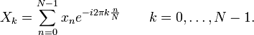
The FFT allows users to obtain the spectral makeup of an audio signal, obtain the decibels of its various frequencies, or obtain the intensity of its various frequencies. The FFT will return both the real and imaginary data components based upon the data given as the real component
STEPS FOLLOWED:-

- Read the given audio signal and get the values of sampling rate and bit resolution
- Plot the original signal.
- Perform FFT on original signal and plot its magnitude and phase.
- Plot FFT of original signal.
- Perform IFFT on FFT signal .
- Plot the IFFT and compare it with original signal.

RESULT:-
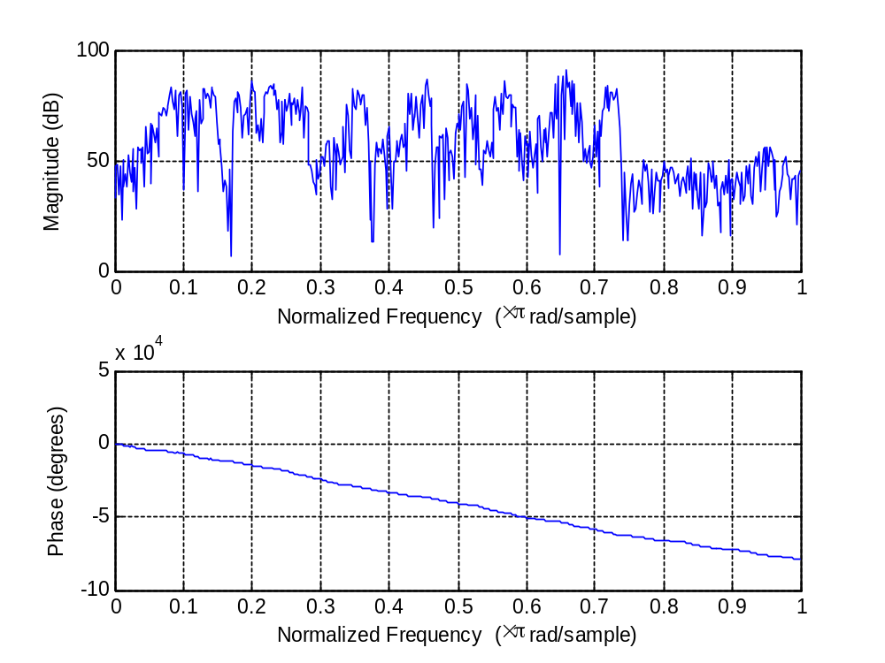
Magnitude and phase plot
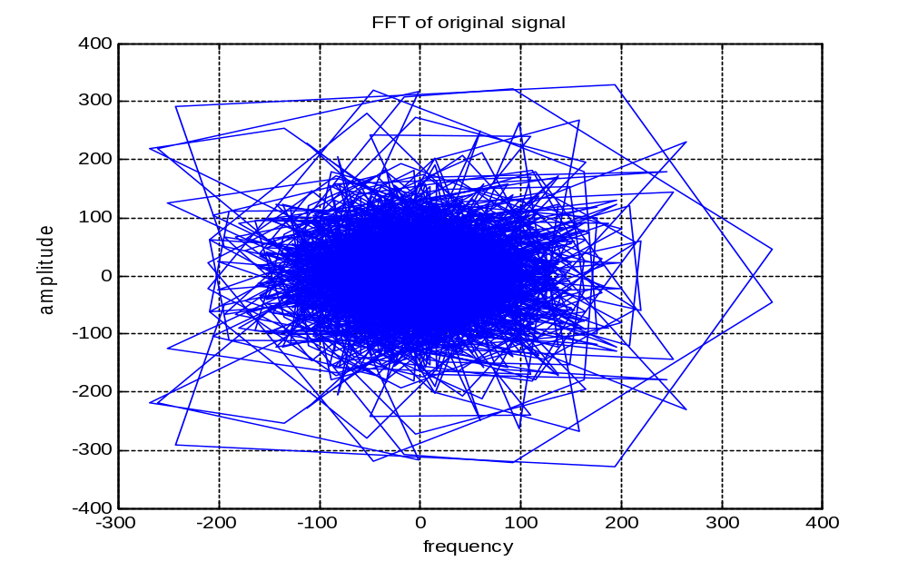
Original signal has been obtained after performing IIFT on FFT signal.

